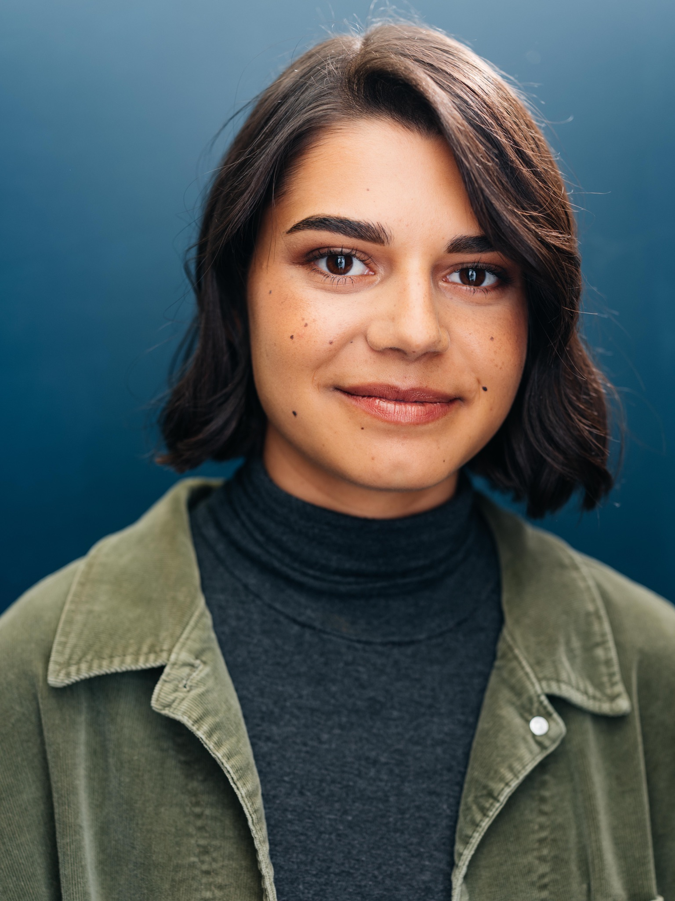
Kell Dezort
kelldezort@gmail.com
400-656-8889

Community Theatre
Shrek Dragon Millennial Theatre Project, Joe Asente, Dir.
Mama Mia Sophie Olde Towne Hall Theatre, Kimberly Mihalik, Dir.
Grease Sandy Sandstone Summer Theatre, Andrew Keller, Dir.
Rent Joanne/ Seasons of Love Soloist MAD Factory, Amber Michalak, Dir.
Les Miserables Cosette MAD Factory, Amber Michalak, Dir

Educational Theatre
Freaky Friday Ensemble Kent State University, Eric Van Baars, Dir.
35 MM Featured Kent State University, Daniel Nadon, Dir.
Parade Ensemble Kent State University, Fabio Polanco, Dir.
Superman in Concert Ensemble Kent State University, Terri Kent, Dir.

Training
Voice: Amber Michalak, Julia Wallace
Dance: Nancy Larson Dance Studio (ballet), Rock City Dance (Contemporary), Olmsted Performing Arts (Ballet)
Kent State University, BFA 2022
Special Skills
Acoustic Guitar, Valid Passport, Valid Ohio Driver’s License, Roller/ Ice Skating, Crocheting, Accents; Valley girl, RP.

